Harley-Davidson Motor Company 3700 W. Juneau Ave., P.O. Box 653, Milwaukee WI 53201

NEWS

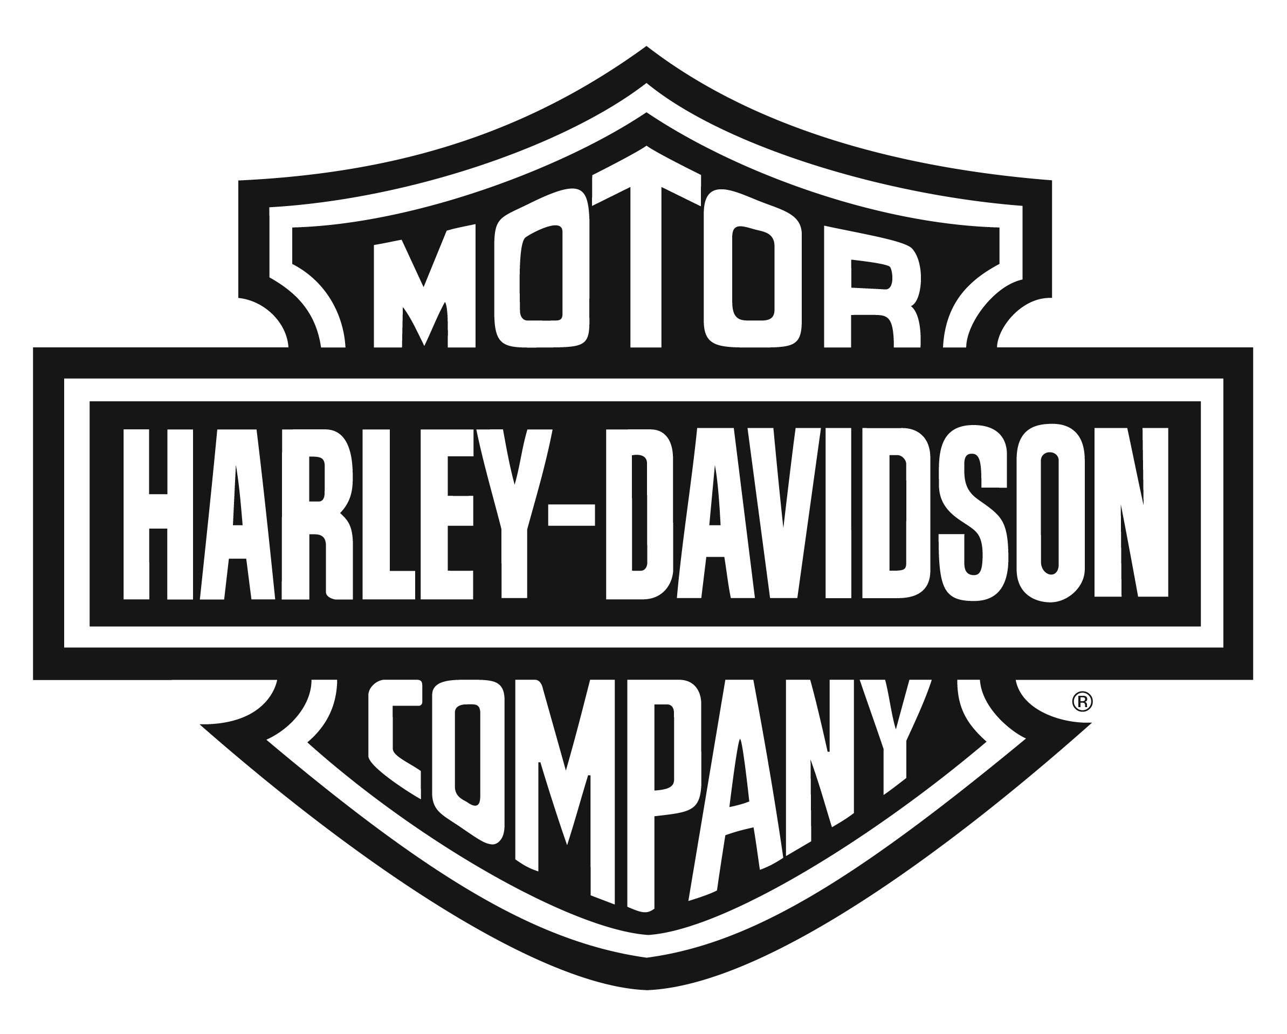

NEW HARLEY-DAVIDSON FORTY-EIGHT SPECIAL AND IRON 1200 SPORTSTERS FUSE THROW-BACK DESIGN WITH MODERN PERFORMANCE
High Handlebars, Cool Graphics, and Garage-Built Attitude

MILWAUKEE (February 21, 2018) – Harley-Davidson adds to the long legacy of its Sportster motorcycle line with the introduction of the Iron 1200 and Forty-Eight Special models. The latest in a line of 100 high-impact motorcycles the company plans to introduce by 2027, these new high-bar Sportsters combine throw-back styling trends from the custom-bike scene with the solid foundation of the Sportster platform and the punchy performance of the Evolution 1200 V-Twin engine.

Since its introduction in 1957, Sportster motorcycles have been repeatedly reimagined, in the hands of both the Motor Company and bike owners: The Sportster as a bobber, a chopper, a scrambler and a café racer; as a hero on flat tracks and drag strips and road-race courses; as an accessible entry-point for first-time riders, and as a custom-of-one cruiser.

“Since its inception, the Sportster has offered the perfect combination of size, power and character that makes it appealing to so many different riders,” said Brad Richards, Harley-Davidson V.P. of Styling & Design. “A Sportster is a relatively easy bike to strip down and reinvent. What we’ve done to create the new Iron 1200 and Forty-Eight Special is what Sportster owners have been doing with their own bikes for generations.”

New fuel tank graphics distinguish both the Iron 1200 and the Forty-Eight Special, and combine bold color stripes with a formal typeface, color and graphic elements originally popular in the 1970s.

“The art on these two fuel tanks reflect contemporary trends we are seeing on custom bikes and in design in general, a move away from more complex and intricate art to a look that’s very simple and clean,” said Richards. “It’s also important to note that these graphics respect the shape of the fuel tank and in the case of the Sportster, that tank shape is a classic design element in its own right.”

Iron 1200™
The Iron 1200 recipe starts with power. A 1202cc Evolution® 1200 V-Twin engine delivers 36 percent more torque (73.0 ft. lbs. vs. 53.8 ft. lb.) than the 883 Evolution engine that powers the Iron 883, the original urban brawler in the Sportster family. The Iron 1200 brings more punch to the street fight – more power to blast away from green lights and more mid-range to muscle through traffic. More power means more rowdy fun.

The satin-black Mini Ape handle bar is an essential element of the garage-built chopper look that adds instant attitude. This 1.0-inch diameter handlebar offers an 8.75-inch rise, 32-inch spread and 6.5-inch pull back, that opens the rider triangle with a fist-in-the-wind posture. The gloss black speed screen framing the headlamp is a West Coast styling influence that amplifies the attitude of the tall bars, is intended to offer some wind deflection at speed and provides a space for easy personalization. The fast-back Café Solo Seat flows to the rear fender and is shaped to help hold the rider in position when the torque of the Evolution 1200 kicks in.

A classic 3.3-gallon Sportster fuel tank features multi-colored striped graphics that wrap around the tank profile. The dark engine finish helps draw the eyes to the bright tank graphics. Fuel tank paint color options include Vivid Black, Twisted Cherry and Billiard White, always contrasting with the Vivid Black speed screen.

The entire powertrain has been styled with a popular color: black upper and lower rocker boxes, black exhaust and muffler shields, and black timer, primary and derby covers. Chrome pushrod tubes and tappet covers are the only brightwork and highlight the V-Twin engine shape. The Iron 1200 is finished with all-black 9-Spoke wheels (19-inch front and 16-inch rear diameter) and a solid black belt guard and rear sprocket.

The Harley-Davidson Smart Security System and anti-lock braking system (ABS) are factory-installed options for the Iron 1200 model.

Forty-Eight® Special
The burly front end of the Forty-Eight Special – a 130mm front tire framed by 49mm forks secured in massive forged aluminum triple clamps – looks especially menacing when topped with a gloss-black, 7.25-inch high Tallboy handlebar.

“We specifically selected the Tallboy bar for its shape,” said Richards. “It offers less pull-back than the Mini-Ape, a look that really works with the steamroller front end and the smaller fuel tank on the Forty-Eight Special model.”

That 2.2-gallon “peanut” Sportster fuel tank features rows of bold, horizontal stripes framing a simple Harley-Davidson text logo. The fuel tank is available in three color options: Vivid Black, Wicked Red, and Billiard White.

The Evolution 1200 engine features a black top end and an expanse of brilliant chrome below, including chrome primary, inspection and derby covers, and solid chrome muffler and exhaust shields. Chrome lower rocker boxes, pushrod tubes and tappet covers contrast with the black cylinders to highlight the V-Twin engine shape. High-performance Michelin Scorcher 31 tires front and rear are mounted on Black Split 9-Spoke Cast Aluminum wheels (16-inch diameter front and rear).

The Harley-Davidson Smart Security System and anti-lock braking system (ABS) are factory-installed options for the Forty-Eight Special model.

About Harley-Davidson Motor Company
Since 1903, Harley-Davidson Motor Company has fulfilled dreams of personal freedom with cruiser, touring and custom motorcycles, riding experiences and events, and a complete line of Harley-Davidson motorcycle parts, accessories, general merchandise, riding gear and apparel. For more information, visit www.h-d.com.

###

